ECEN 616 Example Problems 2-7
Adam Birchfield, Texas A&M University, 9/3/2022
For each problem, solve a simplified version analytically, then create the simplified version in EMTP, then created the full model in EMTP and compare all results.

2. Determine the current $i$, voltages $v_{s}$and $v_{o}$, from before the switch, immediately after, and in the final steady state. Sketch the plot of $i$, including the time constant. What would happen if the switch were reopened after reaching steady state? Assume that in this case there is an 80 $kΩ$ resistor in parallel with the inductor.

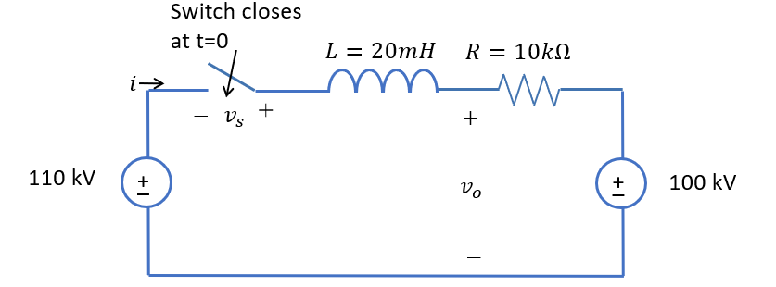

3. This circuit represents the field coil of an electric machine. For startup, simulate the transient of S1 closing. The function of R2 is to aid with disconnecting the field winding. During shutdown, S1 is opened and S2 is closed simultaneously. Determine the power lost by Rf in steady state and the total energy dissipated in R2 during shutdown.
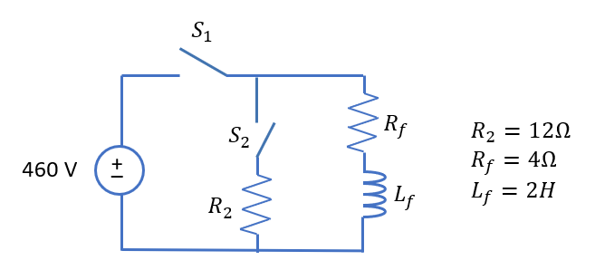

4. Solve this circuit for general variables V, $θ$, R, and L. Then test values of your analytical solution against specific results from EMTP.
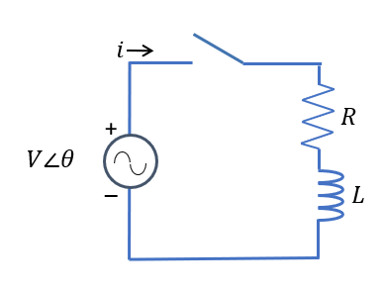

5. In this substation, we are switching in two capacitors $C_{1}$ and $C_{2}$. This is a 34.5 kV bus, with a source that is solidly grounded and has 25 kA rms of symmetrical short circuit current. Neglect all resistances. Capacitor 1 is an 18 MVA bank and capacitor 2 is a 10 MVA bank. Calculate the peak inrush current of closing C1 with C2 open. Then calculate the peak inrush current for closing C2 with C1 already closed. Assume that the bus bar has an inductance of 0.3 $μH/ft$.

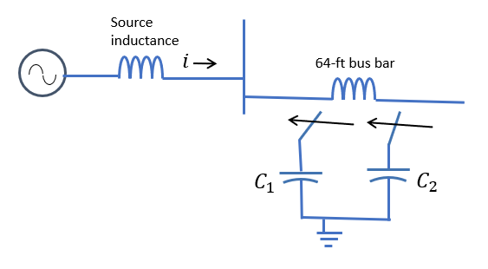

6. For the distribution system shown below, assuming the bus breaker is open, what are the transients associated with switching the capacitor in? Model transformers with impedance referred to the low side, and the motors as either parallel RL (simplified) or voltage behind reactance (full), or neglect them (very simplified).
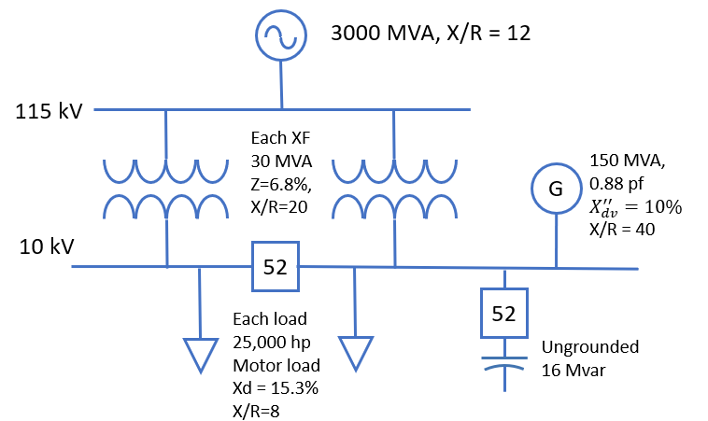

7. How does (3) change if the bus breaker is closed?

