ECEN 616 Example Problem 1
Adam Birchfield, Texas A&M University, 8/22/2022

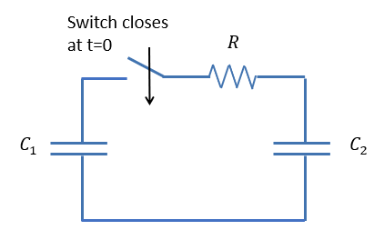
$C_{1}=120 μF$
$C_{2}=80μF$
$R=10 Ω$
Initial charge on $C_{1}$ is 2 Coulombs.
Initial charge on $C_{2}$ is 0.

Solve the differential equations associated with this circuit to answer the following questions:
1. How much energy is lost in the resistor?
2. How much energy do the two capacitors have before the switch and after the transient has settled down (final value)?
3. What is the initial and final voltage on each capacitor?
4. How can you show that energy is conserved in this system?
5. If you are designing this switch, how much current does it need to be able to handle?

Next, solve the same problem replacing the resistor with a 26.5 mH inductor.

